**Lesson14 Understanding Docker Containers**

**Notes: -**

**1-in the first architecture deploying 3 apps in the same physical server , all three apps share the dependencies , so if you upgrade the second app with update Its dependencies , so it will make issue on the first app.**

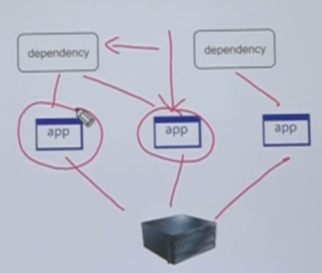

**2-the second architecture deploying each app in separate VM and each one has it’s own**

**Resources of CPU and RAM and dependencies using Hypervisor tools like VM ware.**

**(but the increase number of VMS will reflect negative of performance of CPU and RAM of physical server)**

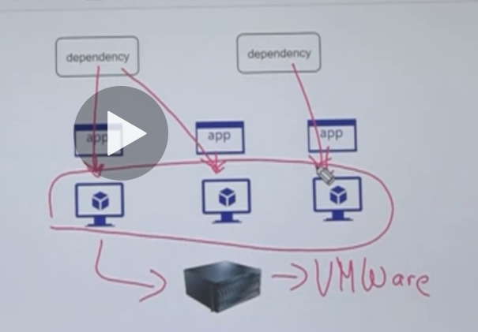

**3-the third architecture instead of create 3 VM and apply each app on single VM, we can create single VM with install constrainer toolbox like Docker**

**(so, 1 VM contains three containers each container has lightweight O.S)**

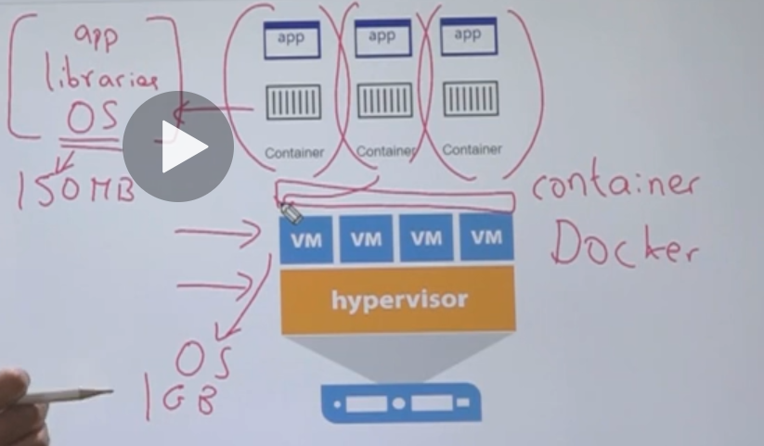

**Lesson15 What is Docker**

**Notes: -**

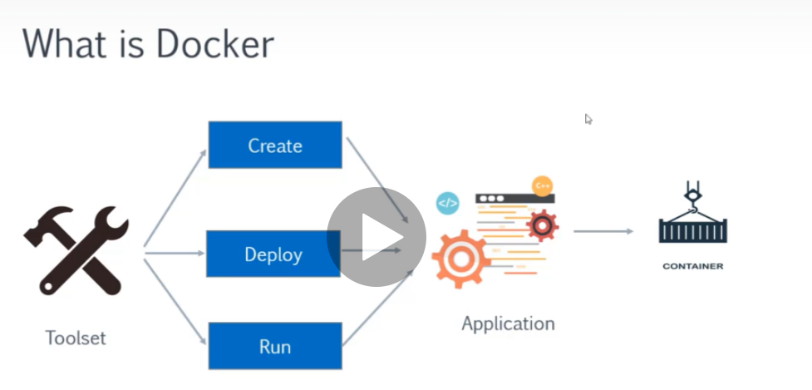

**Docker is toolset that used to create containers and deploy & run application inside these containers**

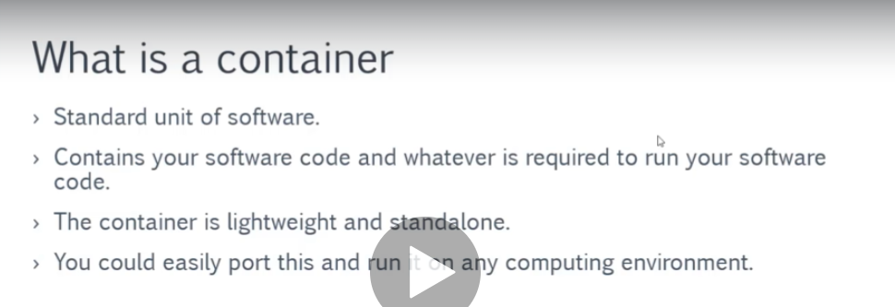

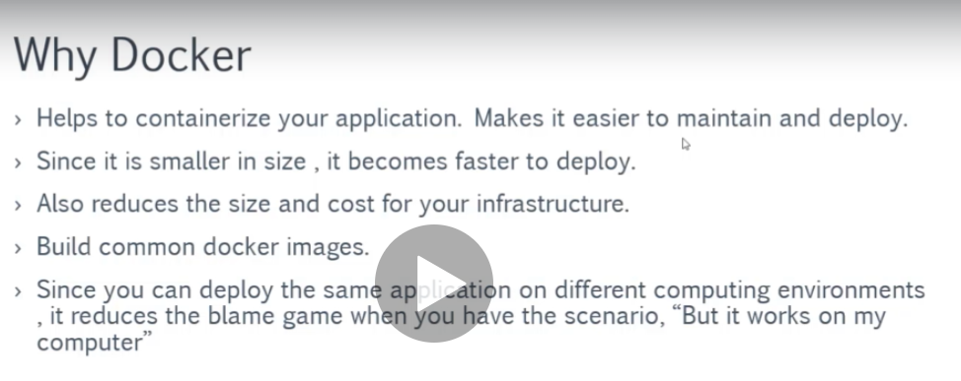

**With docker it will ensure that the same app on the same container can works on any computing environment on any O.S**

**Docker container O.S must be the same of the physical server O.S**